- The announcement of a smaller-than-expected cut in the Energy Price Cap reduces the chances that UK inflation will drop below 2% in April. But the scale of increases in other regulated and indexed prices will likely be the decisive factor in whether inflation dips below target.
- Bank of England Governor Andrew Bailey's testimony to the Treasury Select Committee offered few clues about whether he will vote to cut interest rates in March or April. We think the decision is more finely balanced than current market pricing suggests.
- The UK could be one of the biggest losers from new US tariffs if President Trump follows through on his threat to raise the global tariff rate to 15%. But our modelling suggests the macroeconomic impact of such a move would be very small.
There's a broad consensus that inflation will fall sharply from April, and one piece of the jigsaw dropped into place this week with the announcement that Ofgem's Energy Price Cap will be cut by 6.7% on April 1. Still, this drop was at the lower end of our expectations, and smaller than the Bank of England's assumption that it would fall by 8%. So, it reduces the chances that CPI inflation will dip below the 2% target that month.
The downward pressure on the EPC came from lower wholesale prices and the policy changes announced in November's Budget. The Energy Company Obligation and Great British Insulation Scheme allowance will no longer be funded from energy bills, while the Renewable Obligation allowance was reduced by 75%. But the impact was mitigated by a large increase in network costs (Chart 1).
Though a lower EPC will exert a sizeable drag on inflation in April, the scale of increases in other regulated and index-linked prices will likely have a greater bearing on the outturn. As we outlined in a note published this week, while we think the increases will be smaller than last year, the rises will still be large relative to historical averages. As a result, we expect inflation to come in slightly higher than 2% in April. Furthermore, given the ongoing stickiness of services inflation, we think inflation will edge higher in the second half of the year.
Chart 1: The Ofgem price cap fell by less than expected due to a large rise in the network allowance
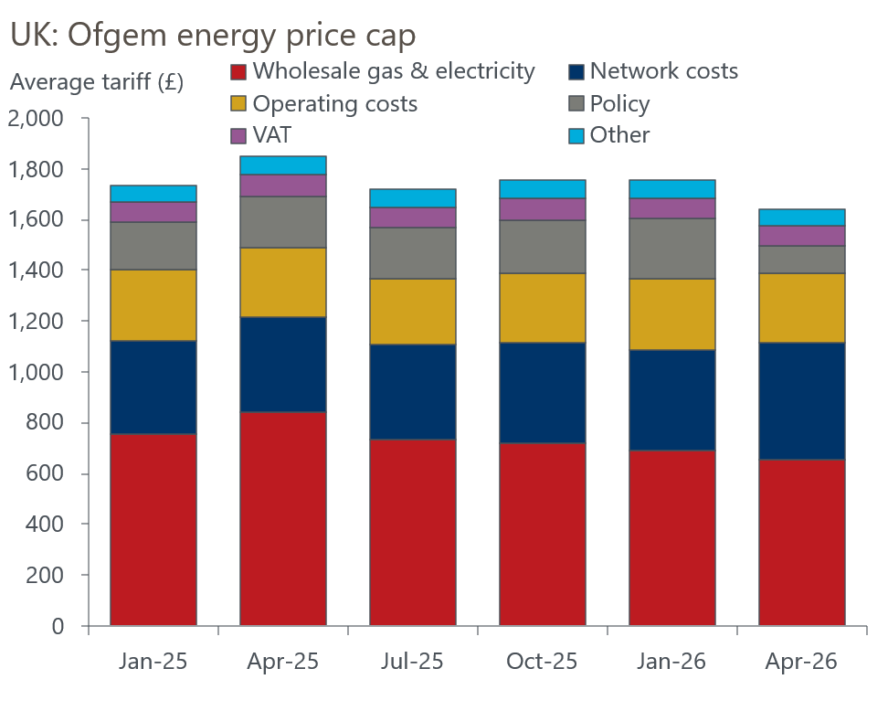
Sources: Ofgem

While there's much focus on April's likely inflation outturn, it won't be a factor in the near-term monetary policy debate. The April inflation data won't be available until mid-May, and it's likely that the BoE's Monetary Policy Committee will already have cut Bank Rate by that stage.
Four MPC members gave testimony to the Treasury Select Committee. Longstanding hawks, Huw Pill and Megan Greene, reiterated that they were more concerned about the upside risks to inflation than the downside risks to demand. On the other side of the MPC divide, Alan Taylor gave the impression he would continue to vote for rate cuts, given his view that inflation expectations were well anchored and that he remains concerned about the resilience of activity in the face of tight monetary policy.
The views of those members have been well entrenched for some time. Governor Andrew Bailey has long been the swing voter, and ultimately his views will likely prove decisive in terms of whether the next cut comes in March or April. We'd hoped the Governor's testimony might provide a steer on that question, but in the event, we learned very little. Bailey said that he expected rates to fall further this year, but that it would have been premature to cut in February. He didn't volunteer a view on last week's wage and inflation data, and the TSC failed to press him on it. So, in Bailey's own words, whether there's a cut in March is still a "genuinely open question".
At Thursday's close, market pricing implied an 80% chance of a March cut (Chart 2). However, the MPC will see another inflation release before it makes its March decision, and though the labour market data will only be published on the morning of the MPC announcement, the BoE typically agrees pre-release access to the data with the Office for National Statistics and the committee will be able to factor it into its deliberations. So there's still plenty of scope for market pricing to move before the March meeting.
Chart 2: Since February's dovish hold, market pricing has firmed behind a March cut
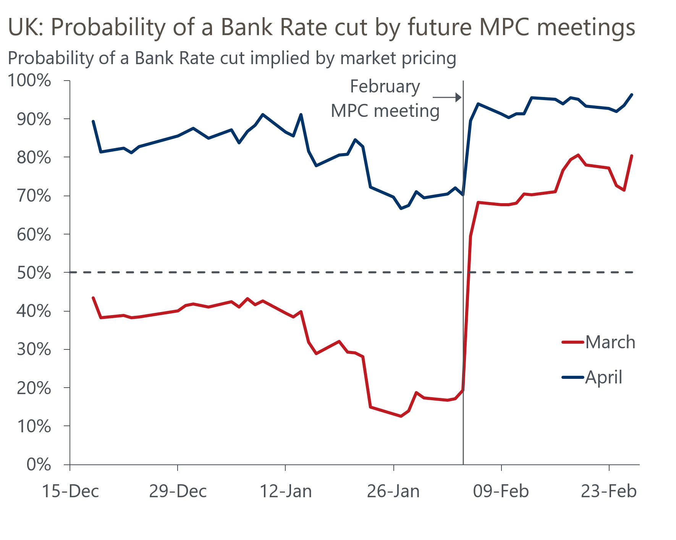
Source: Oxford Economics calculations using data from Haver Analytics
Given the decision will effectively rest on one vote, we still think the question of whether it will be March or April is finely balanced. But if market pricing continues to provide such a clear steer, and if Bailey is ultimately indifferent on timing between the two meetings, then a March cut could become a self-fulfilling prophecy.
Finally, after the US Supreme Court struck down his IEEPA tariffs, President Trump has opted to impose a 10% across-the-board US import tariff that will apply for at least the next 150 days. He has also signalled that he plans to raise the rate to 15%, which would mean the overall effective tariff rate remains broadly similar to the rate prior to the IEEPA ruling.
Our next baseline forecast, released on March 10, will incorporate the global 15% tariff – in line with the Trump administration's stated aim – and maintain the existing exemptions. It will also assume that the administration replicates the same overall tariff level after the 150-day period, using other, more legally durable trade-remedy enforcement mechanisms. Along with Australia, the UK appears to be the biggest loser from these changes, given it previously benefited from a lower 10% reciprocal tariff rate. But even so, scenarios run on our Global Economic Model suggest the macroeconomic impact will be very small.

The week ahead
The Office for Budget Responsibility's Spring forecast should be a low-key affair. Only three months have passed since the Budget, and with the OBR without a chair and the Chancellor saying there will be no policy changes, it will largely be a box-ticking exercise to satisfy the legal requirement for a second forecast in the fiscal year.
Turning to the data, we think that December's surprise slump in mortgage approvals will prove to be a one-off. Christmas means fewer working days and plenty of distractions from home buying, so December is typically a low-activity month. This means the BoE must apply a large seasonal adjustment to the raw data, and volatility is not uncommon. With mortgage affordability much improved, the housing market is in a much better state than in recent years, and we think approvals will have rebounded to more normal levels of around 64,000 in January. We expect net secured lending to come in at £4.7bn.
Consumer credit has bounced around in recent months due to volatile repayments. Assuming repayments drop back towards recent averages, weaker credit card lending should offset stronger flows in other forms of unsecured lending and leave net unsecured lending little changed at £1.6bn in January.
Table 1: Week ahead calendar
Date | Events | Period | Measure | Unit | Previous | Forecast
Mar 2 | Nationwide house prices | Feb | m/m | % | 0.3 | 0.2
Mar 2 | Nationwide house prices | Feb | y/y | % | 1.0 | 0.6
Mar 2 | Mortgage approvals | Jan | Level | 000s | 61.0 | 64.0
Mar 2 | Mortgage lending | Jan | Net lending | £bn | 4.6 | 4.7
Mar 2 | Consumer credit | Jan | Net lending | £bn | 1.5 | 1.6
Mar 2 | S&P Global manufacturing | Feb | PMI | % bal | 52.0 | 52.0
Mar 3 | OBR spring forecast
Mar 4 | S&P Global services | Feb | PMI | % bal | 53.9 | 53.9
Mar 4 | S&P Global composite | Feb | PMI | % bal | 53.9 | 53.9
Mar 5 | S&P Global construction | Feb | PMI | % bal | 46.4 | 48.0
Source: Oxford Economics

Key forecasts
Table 2: UK forecast overview
(Annual percentage changes unless specified)
 | 2023 | 2024 | 2025 | 2026 | 2027 | 2028
GDP | 0.3 | 1.1 | 1.3 | 0.9 | 1.3 | 1.4
Private consumption | -0.3 | -0.1 | 1.0 | 0.9 | 1.1 | 1.3
Fixed investment | 0.5 | 1.7 | 3.4 | 0.7 | 2.1 | 2.1
Government consumption | 2.1 | 2.9 | 1.7 | 2.0 | 1.7 | 1.4
Exports of goods and services | -2.3 | 1.4 | 1.6 | 1.0 | 1.1 | 1.3
Imports of goods and services | -1.6 | 2.7 | 4.2 | 0.2 | 1.2 | 1.4
Industrial production | -2.6 | -1.3 | 0.3 | 0.7 | 1.0 | 1.2
Consumer prices | 7.3 | 2.5 | 3.4 | 2.5 | 2.6 | 2.4
Unemployment rate (%) | 4.1 | 4.3 | 4.9 | 5.3 | 5.1 | 4.8
Current a/c balance (% of GDP) | -3.6 | -3.0 | -2.8 | -3.1 | -2.8 | -2.6
Government balance (% of GDP) | 5.2 | 5.3 | 5.0 | 3.9 | 3.3 | 2.8
Central bank policy rate (%, EOP) | 5.25 | 4.75 | 3.75 | 3.25 | 3.00 | 2.75
10yr govt. bond yield (%, EOP) | 3.54 | 4.57 | 4.47 | 4.38 | 3.90 | 3.64
Exchange rate (US$ per £, EOP) | 1.27 | 1.25 | 1.35 | 1.31 | 1.30 | 1.30
Exchange rate (euro per £, EOP) | 1.15 | 1.21 | 1.15 | 1.11 | 1.10 | 1.10
Source: Oxford Economics
Table 3: Quarterly forecasts for the UK
 | 2025 |  |  |  | 2026
 | Q1 | Q2 | Q3 | Q4 | Q1 | Q2 | Q3 | Q4
GDP (% year) | 1.8 | 1.4 | 1.2 | 1.0 | 0.7 | 0.8 | 1.0 | 1.2
CPI inflation (% year) | 2.8 | 3.5 | 3.8 | 3.4 | 3.0 | 2.2 | 2.4 | 2.5
Bank Rate (%, EOP) | 4.50 | 4.25 | 4.00 | 3.75 | 3.75 | 3.50 | 3.50 | 3.25
10yr gilt yield (%, EOP) | 4.70 | 4.48 | 4.70 | 4.47 | 4.50 | 4.48 | 4.45 | 4.38
US$ per £ (EOP) | 1.29 | 1.37 | 1.35 | 1.35 | 1.35 | 1.33 | 1.32 | 1.31
Euro per £ (EOP) | 1.20 | 1.17 | 1.15 | 1.15 | 1.15 | 1.13 | 1.12 | 1.11
Source: Oxford Economics

Latest Country Economic Forecast:
February 16, 2026

Recent publications

Data Insights
February's PMI suggests economic momentum remains strong
Bumper January for tax receipts keeps public finances on track
Retail sales volumes soared at the start of 2026
Inflation falls due to base effects and volatile categories
Labour market data consistent with a rate cut in March or April

Research Briefings
The 2026 inflation outlook is a tale of two halves
Lower immigration will hit growth and raise borrowing
Dovish hold prepares the ground for more easing
Would a change in Labour's leadership affect economic policy?
Forecasters' Mailbag – Questions from our conference

Contacts

Oxford Economics' UK team
- Andrew Goodwin - Chief UK Economist - agoodwin@oxfordeconomics.com
- Edward Allenby - Senior UK Economist - eallenby@oxfordeconomics.com

